APPLICATION FORM
for the participation in the
International Scientific-and-Practical Conference
«ACTUAL PROBLEMS OF FOOD SECURITY (ECOLOGICAL, CHEMICAL AND BIOLOGICAL SAFETY, QUALITY AND SAFETY
OF AGRICULTURAL PRODUCTS)»
DEDICATED TO THE 100th ANNIVERSARY
OF ACADEMICIAN GLADENKO I.M.
(June, 8 – 12, 2015, Odessa)
Name

Organization

Position
Tel.
Fax.
E-mail
Address

I would like to take part
in the Congress as a lecture listener
I AM GOING TO:
make a speech oral
poster session
Theme of the speech, authors

Please reserve me a room -

DATE OF
arrival ______________ departure ______________
__________________

Signatureь
Please fill in application form and send it to the address of the Organizing Committee:
e-mail: inform@vet.kharkov.ua
not later than May, 8, 2015

Dear

We invite you to take part in the
International
Scientific-and-Practical Conference
«ACTUAL PROBLEMS OF FOOD SECURITY (ECOLOGICAL, CHEMICAL AND BIOLOGICAL SAFETY, QUALITY AND SAFETY OF AGRICULTURAL PRODUCTS)»
DEDICATED TO THE 100th ANNIVERSARY
OF ACADEMICIAN GLADENKO I.M.
The basic guidelines of the Conference:
- Scientific basis for evaluating the quality and safety of animal products. Risks
of biotic and ksenobiotic contamination of animal products.
- Scientific and methodological support for the control of quality and safety of animal feed and raw materials for their manufacture.
- Modern problems of ecological safety in the context of globalization and anthropogenic threats.
- Evaluation of biological risks and their management at emergent and economically important infectious diseases of animals.
- Scientific aspects of biosafety and biosecurity.
- The improvement of national strategies of food security based on international experience.

Program of the Conference:

8.06.2015

9.00–17.00 Registration of the participants
of the Conference

9.06.2015

9.00–10.00 Registration of the participants
of the Conference

10.00–13.00 Opening of the Conference,
Plenary Session

14.00–17.00 Second Plenary Session

19.00 Social Event
10.06.2015
10.00–13.00 Section Sessions

14.00–17.00 Section Session
11.06.2015
10.00–13.00 Section Sessions

14.00–17.00 Final Plenary Session
12.06.2015
9.00–17.00 Departure of conference participants

Working languages of the Conference:
Russian, Ukrainian, English
Registration fee
for participants of the Conference — 15 €

Scientific articles will be published
in the next book “Veterinary Medicine”.
Dear Colleagues!
During the conference there
will be organized an exhibition of
veterinary preparations, reagents and laboratory equipment.
We invite sponsors for mutually
beneficial cooperation

INFORMATION ON STAY
IN ODESSA
Accommodation of participants, registration, plenary and breakout sessions, as well
as exhibition of veterinary preparations
and laboratory equipment will be at the health resort of Border Service of the Ministry of Defense of Ukraine «Arcadia»
Address of health resort “Arcadia”:
Odessa, Street Haharynske plato 1
health resort “Arcadia”
Cost of accommodation:
From 40 € per one person per day
The prices are indicated
for 13.03.2015
The room price includes 3-meals
.

Directions to the health resort «Arcadia»
from the railway station
and the central bus station to the station
«Rosiyske consulstvo»:
route taxi - 198

ADDRESS OF THE ORGANIZING COMMITTEE OF THE CONFERENCE:
NSC “IECVM”
83, Pushkinskaya Street,
Kharkiv, 61023, Ukraine
Anton Pavlovych Gerilovych
Tel.: +38(057) 707-20-28
antger@vet.kharkov.ua
Olga Mykolaivna Unkovska
Tел.: +38(057) 707-20-01
E-mail : inform@vet.kharkov.ua;
Fax: +38(057) 704-10-90
http://www.iekvm.kharkov.ua/

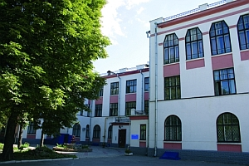
NATIONAL ACADEMY OF AGRARIAN SCIENCES OF UKRAINE

State veterinary and phytosanitary service of ukraine

NATIONAL SCIENTIFIC CENTER ‘INSTITUTE OF EXPERIMENTAL AND CLINICAL VETERINARY MEDICINE’

SRE “Veterinary Medicine” Ltd

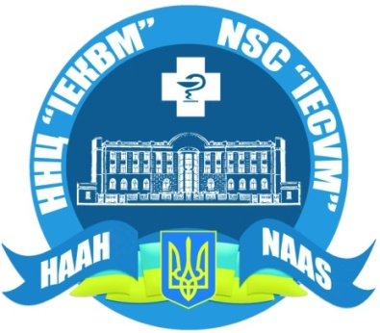

INVITATION

To the International scientific-and practical conference

«ACTUAL PROBLEMS OF FOOD SECURITY (ECOLOGICAL, CHEMICAL AND BIOLOGICAL SAFETY, QUALITY AND SAFETY OF AGRICULTURAL PRODUCTS)»
DEDICATED TO THE 100th ANNIVERSARY
OF ACADEMICIAN GLADENKO I.M.
June, 8 – 12, 2015
Odessa, Ukraine

