APPLICATION FORM
for the participation in the
International Scientific-and-Practical Conference
«TRANSBOUNDARY EMERGENT ANIMAL DISEASES (AFRICAN SWINE FEVER, LUMPY SKIN DISEASE, AVIAN INFLUENZA, BLUETONGUE, BRUCELLOSIS ETC.): ACTUAL ASPECTS OF BIOSAFETY AND CONTROL»
(June, 5 – 9, 2017, Odessa)
Name

Organization

Position
Tel.
Fax.
E-mail
Address

I would like to take part
in the Congress as a lecture listener
I AM GOING TO:
make a speech oral
poster session
Theme of the speech, authors

Please reserve me a room -

DATE OF
arrival ______________ departure ______________
__________________

Signatureь
Please fill in application form and send it to the address of the Organizing Committee:
e-mail: inform@vet.kharkov.ua
not later than May, 8, 2017
Dear

We invite you to take part in the
International
Scientific-and-Practical Conference
«TRANSBOUNDARY EMERGENT ANIMAL DISEASES (AFRICAN SWINE FEVER, LUMPY SKIN DISEASE, AVIAN INFLUENZA, BLUETONGUE, BRUCELLOSIS ETC.): ACTUAL
ASPECTS OF BIOSAFETY
AND CONTROL»
The basic guidelines of the Conference:
- Evaluation of biological risks and risk management at animal transboundary diseases including zoonoses.
- Biosafety and biosecurity aspects.
- Epizootology, epidemiology, monitoring, diagnostics and prevention of transmissible diseases (African swine fever, Lumpy skin disease, Avian influenza, Bluetongue, Brucellosis etc.).
- Ecology and biology of vector- carriers of transmissible infection agents.
- Improvement of national strategies of reduction of biological threat and risks
of transboundary diseases spread taking into account international experience.

Program of the Conference:

5.06.2017

9.00–17.00 Registration of the participants
of the Conference

6.06.2017

9.00–10.00 Registration of the participants
of the Conference

10.00–13.00 Opening of the Conference,
Plenary Session

14.00–17.00 Second Plenary Session

19.00 Social Event
7.06.2017
10.00–13.00 Section Sessions

14.00–17.00 Section Session
8.06.2017
10.00–13.00 Section Sessions

14.00–17.00 Final Plenary Session
9.06.2017
9.00–17.00 Departure of conference participants

Working languages of the Conference:
Russian, Ukrainian, English
Registration fee
for participants of the Conference — 15 €

Scientific articles will be published
in the next book “Veterinary Medicine”.
Dear Colleagues!
During the conference there
will be organized an exhibition
of veterinary preparations, reagents
and laboratory equipment.
We invite sponsors for mutually
beneficial cooperation

INFORMATION ON STAY
IN ODESSA
Accommodation of participants, registration, plenary and breakout sessions, as well
as exhibition of veterinary preparations
and laboratory equipment will be
at the hotel complex "Kurortnyi"
Address of the hotel complex "Kurortnyi":
Kurortnyi provulok, 2, Odessa,
Ukraine, 65009
hotel complex "Kurortnyi"

Cost of accommodation:
From 40 € per one person per day
The prices are indicated
for 20.03.2017
The room price includes 3-meals

Directions to hotel "Kurortnyi"
from the railway station
to the 10 Aprelia square:
route taxi - № 242, 198, 115
Tram - № 5
Trolley - № 7

ADDRESS OF THE ORGANIZING COMMITTEE OF THE CONFERENCE:
NSC “IECVM”
83, Pushkinskaya Street,
Kharkiv, 61023, Ukraine
Anton Pavlovych Gerilovych
Tel.: +38(057) 707-20-28
antger2011@gmail.com
Olga Mykolaivna Unkovska
Tел.: +38(057) 707-20-01
E-mail : inform@vet.kharkov.ua;
Fax: +38(057) 704-10-90
http://www.iekvm.kharkov.ua/

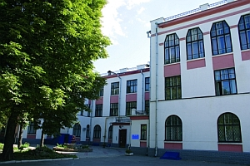
NATIONAL ACADEMY OF AGRARIAN
SCIENCES OF UKRAINE
NATIONAL SCIENTIFIC CENTER ‘INSTITUTE
OF EXPERIMENTAL AND CLINICAL
VETERINARY MEDICINE’
INSTITUTE OF VETERINARY
MEDICINE NAAS OF UKRAINE
UKRAINIAN ASSOCIATION
OF BIOSAFETY
SI “L.V. GROMASHEVSKY INSTITUTE
OF EPDEMIOLOGY AND INFECTIOUS
DISEASES OF NAMS OF UKRAINE”
SI "MECHNIKOV ANTIPLAGUE UKRAINIAN SCIENTIFIC RESEARCH INSTITUTE" OF THE MINISTRY OF HEALTH OF UKRAINE
SRE “Veterinary Medicine” Ltd

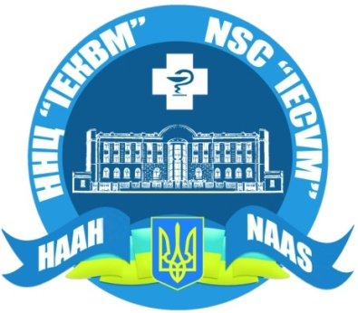

INVITATION

To the International Scientific-and Practical Conference

«TRANSBOUNDARY EMERGENT
ANIMAL DISEASES (AFRICAN SWINE FEVER, LUMPY SKIN DISEASE,
AVIAN INFLUENZA, BLUETONGUE, BRUCELLOSIS ETC.): ACTUAL ASPECTS OF BIOSAFETY AND CONTROL»
June, 5 – 9, 2017
Odessa, Ukraine

