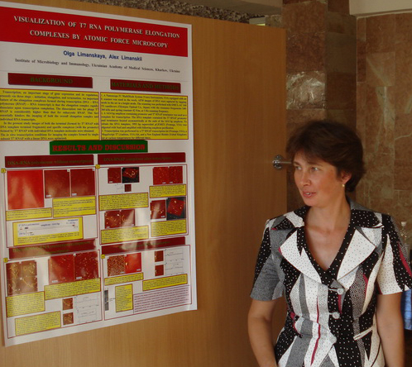
Limanskaya Olga, Dr. Sci., Research Professor, Chief Scientist
Research Activities/Interests:

Molecular technologies of detection and genotyping bacterial and viral pathogens based on the different modifications of polymerase chain reaction, isothermal amplification.

Bioinformatics (genomics, phylogenetic analysis, search of molecular regulators in the genome of bacteria and viruses including RNA thermometers, structural organization of the genome of pathogens.

Molecular biology of nucleic acids – (melting of DNA and oligonucleotides, thermodynamics of drug – DNA interaction.

Prof. Limanskaya O. is the author more than 110 papers including 12 patents of Ukraine.

Homepage: http://www.iekvm.kharkov.ua/personal/Limanskaya/Limanskaya_homepage.html
E. mail: olga.limanskaya@mail.ru

